**Lesson Topic: Making Informed Decisions**

**Objectives:**

* Understand abstinence is a conscious decision for any time and for any duration
* Identify steps involved in a decision making model
* Describe the impact people have on students sexual decision making
* Analyze source accuracy and reliability of sexual health information

**Activities:**

Abstinence Continuum

Abstinence: Yes/No/Maybe So?

Other’s Opinions Activity

Decision making

Is it a Good Resource?

**Abstinence Continuum**

* Draw a continuum line on the board and number from 0-10. (0-more negative to 10-more positive) Pass out index cards, scrap squares or post-its and have students, indicate with a number how they feel most teens would feel about sexual abstinence.
* Ask for volunteers to share and their reasons.

**Abstinence and Sex have different meanings to different people**

* Write the following sentence stems on the board and have students respond on their index card
  + Sexual abstinence means…
  + When people say *having sex*, they mean…
  + Someone who abstains from “sex” can still…
* Have students get in pairs and discuss their responses to the above question stems.
  + What similarities and differences did you notice between your responses?
  + Some people say that *having sex* means the same things as *having sexual intercourse*. Do you agree? Why? If you disagree, what else could *having sex* mean?
  + What did you and your partner do when you had differing responses?
  + Why is it important for a person to be very clear about his or her own definition of *abstinence* and *having sex*?

**Abstinence: What does it mean?**

* Like people, information sources have varying ideas of what abstinence means. Generally people start with the dictionary when deciphering the meaning of a word, Read the following dictionary definition…

1. the practice of [abstaining](https://www.merriam-webster.com/dictionary/abstain) from something **:** the practice of not doing or having something that is wanted or enjoyable
2. **a** **:** habitual [abstaining](https://www.merriam-webster.com/dictionary/abstain) from intoxicating beverages

**b** **:** abstention from sexual intercourse

Source: <https://www.merriam-webster.com/dictionary/abstinence>

* Did this definition help you understand the meaning of abstinence and why or why not?
  + - Note, it’s very important to have a personal definition of what abstinence means to you.
    - What does sexual intercourse mean? Does that mean that oral sex is ok?

Slide 2: WCSD Definition of Abstinence

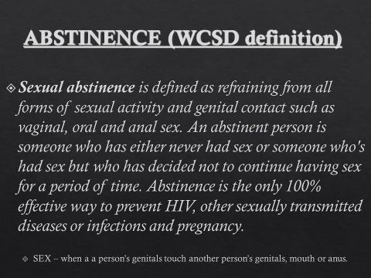

Working definition of Abstinence: For these SHARE lessons, we will use the **WCSD definition of Abstinence.**

* + **Sexual Abstinence is defined as refraining from all forms of sexual activity and genital contact such as vaginal, oral and anal sex.**
  + **An abstinent person is someone who has either never had sex or someone who’s had sex but who has decided not to continue having sex for a period of time.**
  + **Abstinence is the only 100% effective way to prevent HIV, other sexually transmitted diseases or infections and pregnancy.** 
    - SEX-when a person’s genitals touch another person’s genitals, mouth or anus.

Slide 3: NV Abstinence Data-CDC 2017 Your Risk Behavior Survey

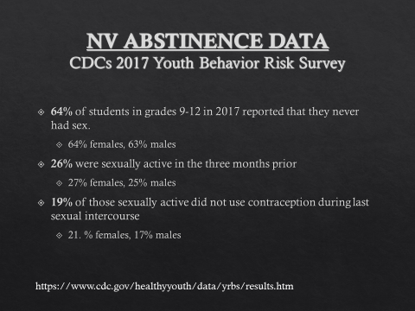

**Abstinence: Yes/No/Maybe So?**

Go over Abstinence PowerPoint

Slides 4-20

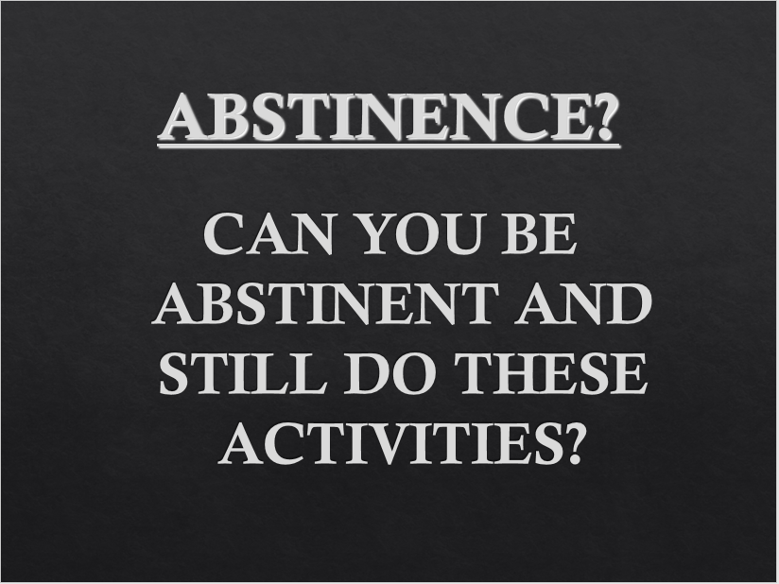

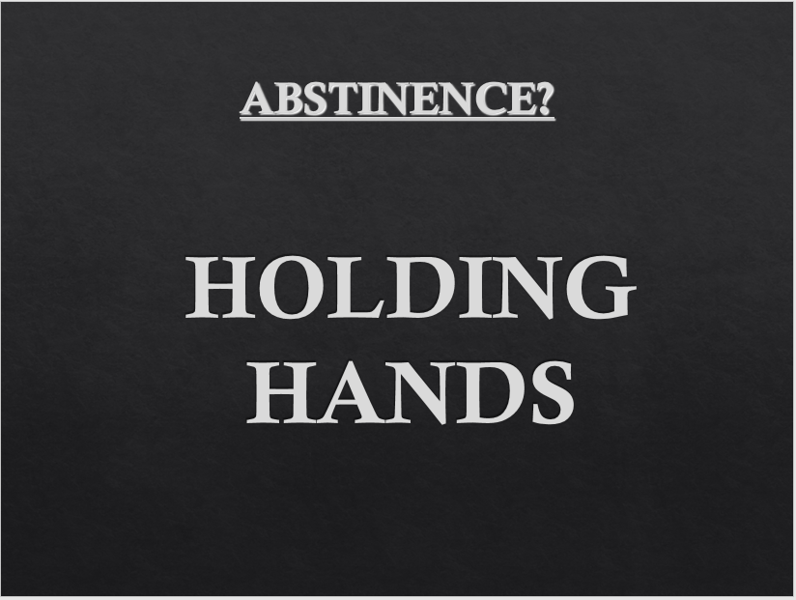

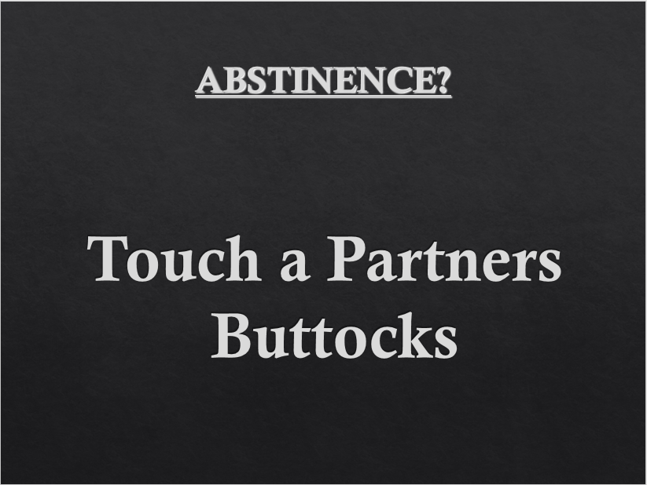

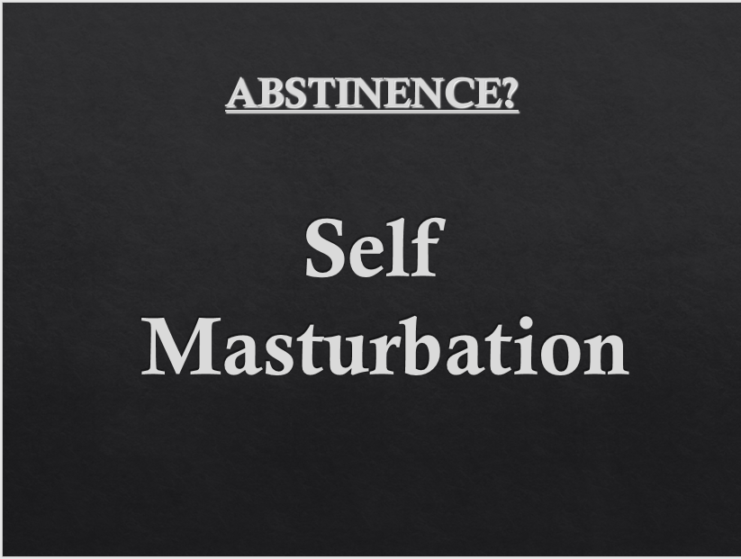

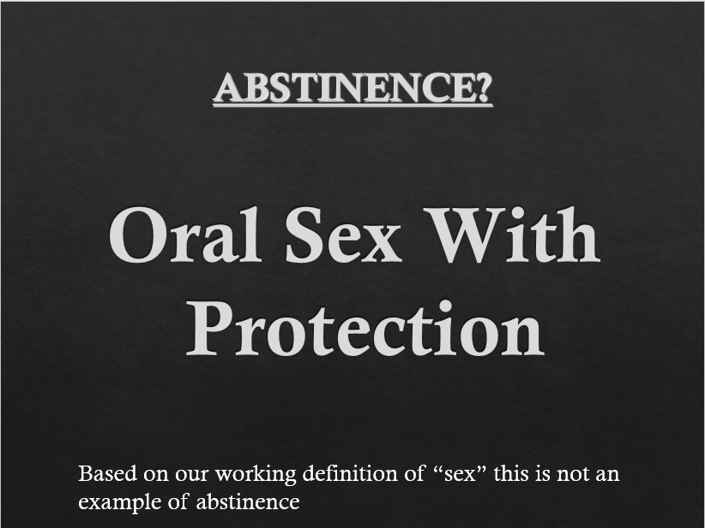

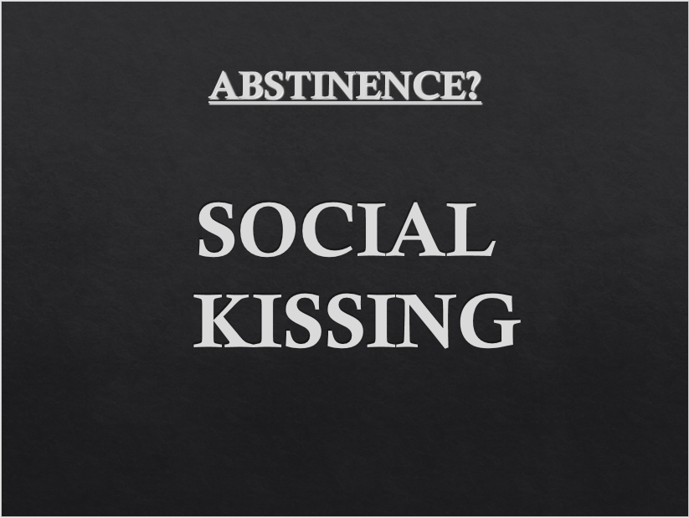

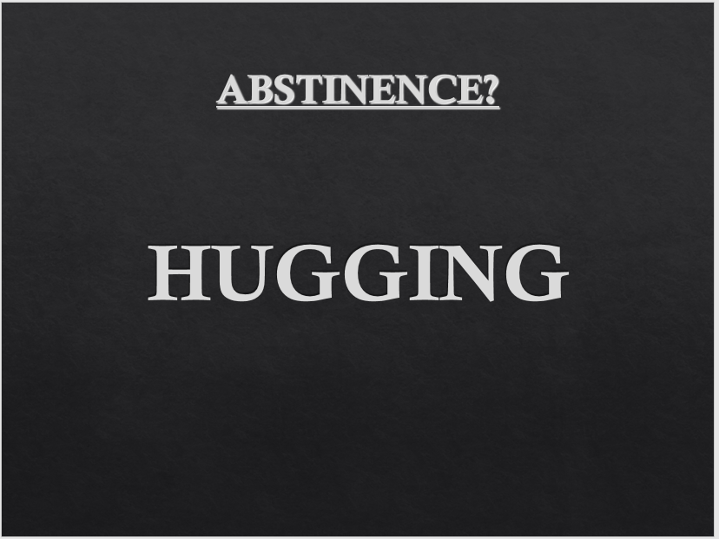

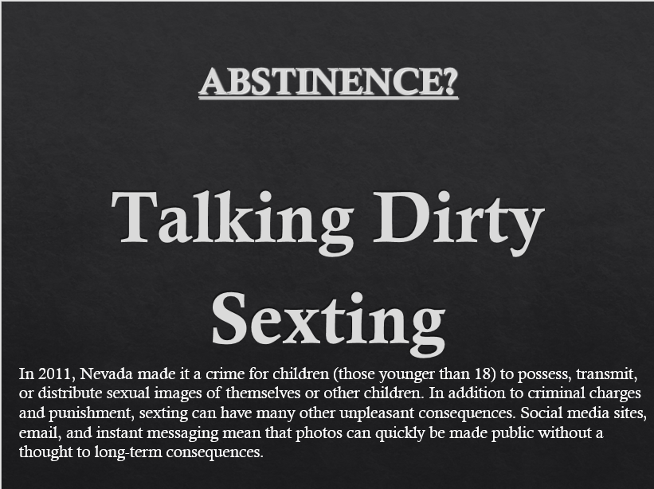

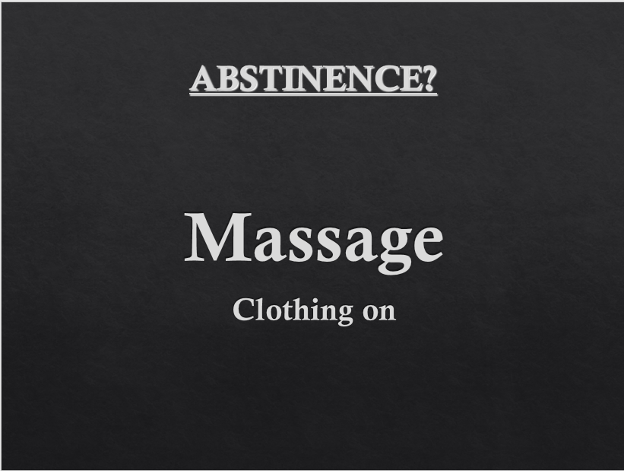

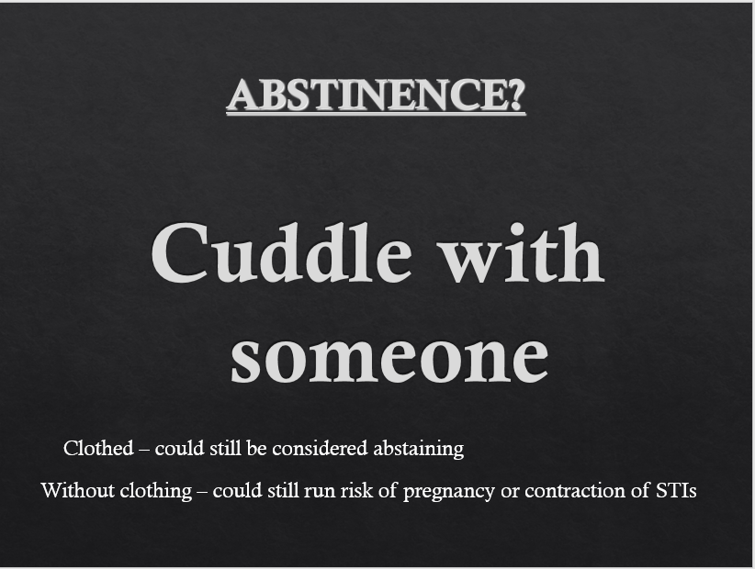

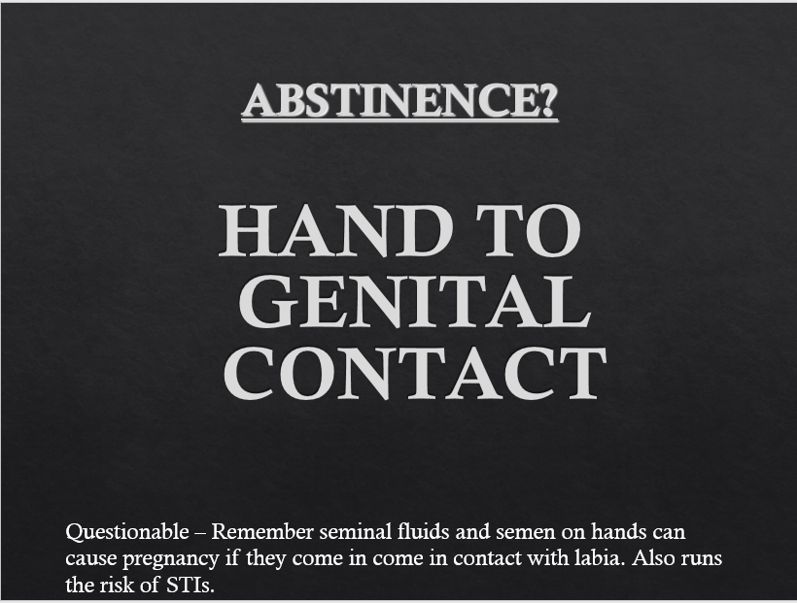

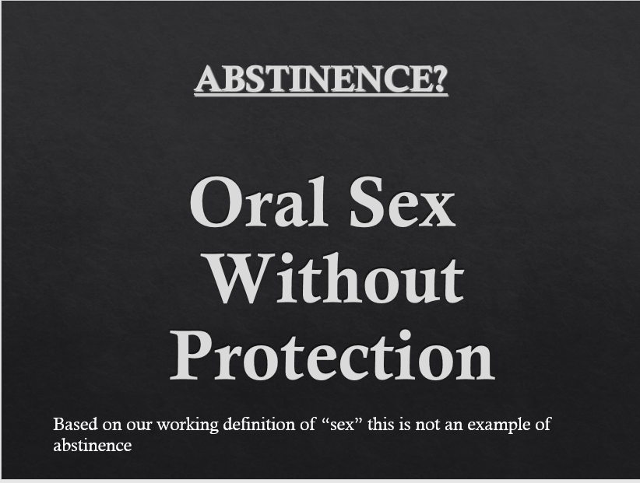

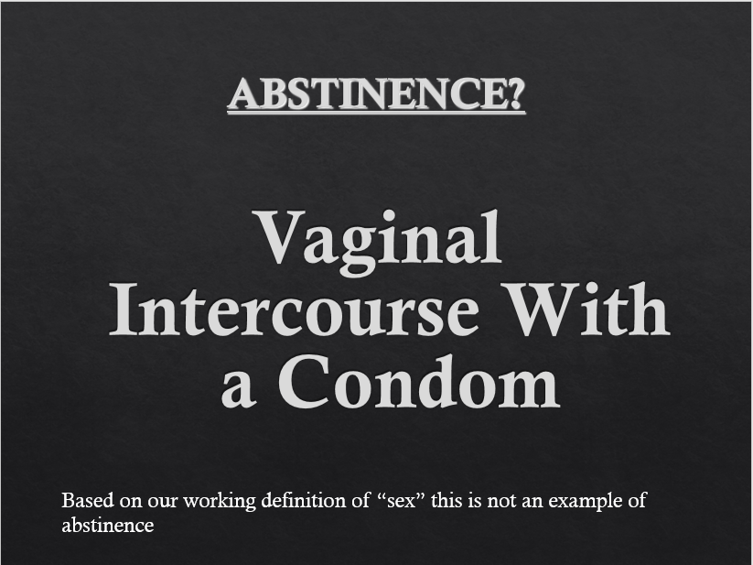

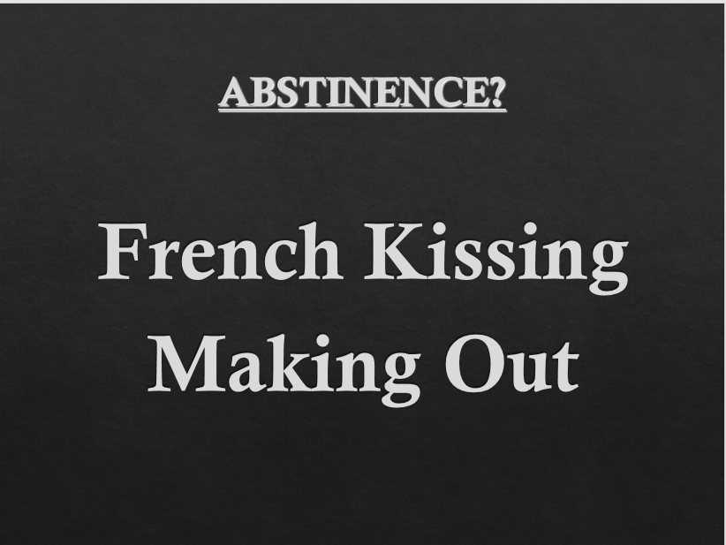

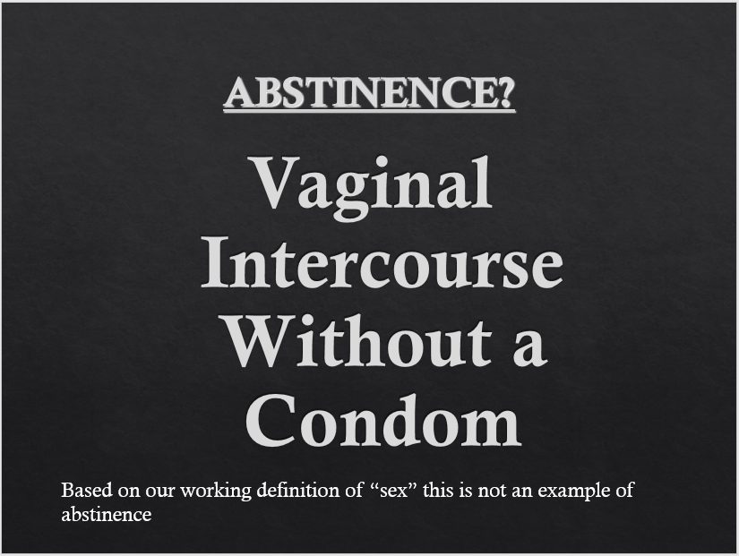

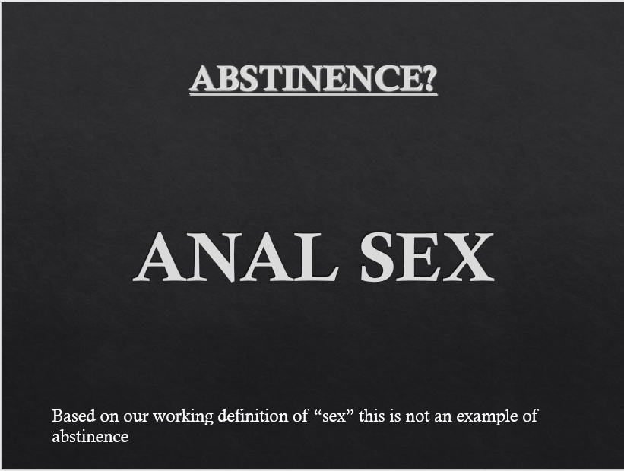

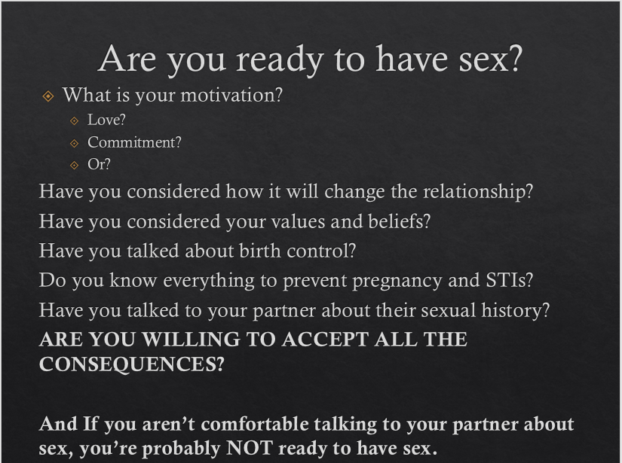

Are You Ready to Have Sex? (The last slide on the Abstinence PowerPoint)

* Have you ever said or done something to someone that immediately after you asked yourself, “Why did I do that?”
  + Have students share responses and how they felt afterwards.
  + Unfortunately it’s something we all do-and not just once, we continue throughout our lives.
    - Sometimes our decisions are made without thinking
    - Some we think are very well thought out and still wish we wouldn’t have made it.
* What decisions have you made that had positive outcomes? (students share)
* What decisions have you made that had negative outcomes? (students share)

**Sexual decision making… what and who can have an impact on the decisions we make**

* **Other’s Opinions Activity**- (Located at end of document)
  + Explain that having support of family and loved ones can be very important along with communicating with other adults when trying to make important decisions.
  + Pass out the sheet and explain that in the left hand column are questions to think about when considering a sexual relationship. Along the top are individuals you might have in your lives.
  + Read each statement and predict how each individual might respond.
    - Students complete activity individually
    - When finished students turn to a partner and respond to the following questions.
      * How did you know what these people would say?
      * What were their messages, positive or negative
      * In what ways do you think the people listed affect or would affect the decision you make about sexuality and why?
* What other things come into play when making decisions about sex and sexuality?
  + Have students brainstorm things that may influence their decisions.
    - *Possible responses*
      * *Past experience-positive*
      * *Past experience-negative*
      * *What my personal/religious values are about the behavior or having sex*
      * *How I feel about my body*
      * *My understanding of my sexual orientation*
      * *What I see depicted in the media or have seen on the internet*
* We don’t live in a silo…
  + People are influenced by both people and the world around us.
  + In the end, you are the one who benefits from your positive decisions.
  + And has to deal with the possible negative consequences of a bad decision.

**Steps to decision making (to avoid “why did I do that?)**

* Brainstorm decisions students make every day
  + Breakfast choice
  + What to wear
  + Who to sit with at lunch
  + Etc.
* You didn’t spend a great deal of time making those decisions.
* Decisions about sex and sexuality are not quick decisions.
* Write the word Decision on board
  + Explain that decisions are based on the values or principles or beliefs we have
    - Informed by family, friends, or perhaps a religious belief, and our own thoughts and beliefs.
  + When it comes to sexuality related decisions, think about the following…
    - Determine what the situation is
    - Brainstorm your options
    - Gather information- weigh pros/cons
    - **Make a decision**
    - Act on your decision
  + Go over the above steps with choosing to eat a Snickers bar for breakfast.
* What’s Your Decision? Can be done whole group or small group.
* Now we are going to move on to something far more serious…the decision whether or not to have sex.

**INSTRUCTIONS:** Read the following scenario. Decide whether you want to represent Mario

or Daisy, then walk through a decision-making model and make your choice!

Mario and Daisy have been together since the beginning of 9th grade. They’ve made out

a lot and know how to make each other feel good, and haven’t really had any complaints

about that part of their relationship. It’s almost the end of 10th grade, and they both are wondering if they are ready to start having sex. Neither of them has ever had sex. Mario and Daisy don’t want Daisy to get pregnant, but they’re not sure what their options are for protection. Neither of them will have sex without some kind of protection.

Character You’re Representing (circle one): Mario Daisy

**Determine what the Situation is**

_____________________________________________________________

_____________________________________________________________

**Brainstorm your Options**

_____________________________________________________________

_____________________________________________________________

**Gather Information about and weigh the of Pros and Cons of Those Options**

_____________________________________________________________

_____________________________________________________________

**Make a Decision**

_____________________________________________________________

_____________________________________________________________

**Act on Your Decision**

_____________________________________________________________

_____________________________________________________________

* Have groups share responses.
* **Make sure to point out that whatever decision you make, you want to think it through carefully before making it.**

**Is it a Good Resource?**

* Things to consider when looking at online resources for accuracy
  + Who said it? What do you think about the reliability of this source?
  + When did they say it? Is the information current?
  + How did they know? Is the information accurate and free from bias?
  + Would you recommend this website to your friends? Why or why not?
* Websites:
  + CDC: <https://www.cdc.gov/teenpregnancy/teens/index.htm>
  + Girls Health: <https://www.girlshealth.gov/>
  + Go Ask Alice: <https://goaskalice.columbia.edu/>
  + HHS: https://www.hhs.gov/ash/oah/adolescent-development/healthy-relationships/dating/index.html
  + I Wanna Know: <http://www.iwannaknow.org/teens/relationships.html>
  + Nevada 211 (multi resource); <https://www.nevada211.org/youth-services/>
  + Northern Nevada Hopes: https://www.nnhopes.org/
  + Our Center: http://www.ourcenterreno.org/
  + Planned Parenthood: https://www.plannedparenthood.org/learn/teens
  + Reno Youth Network: <https://www.renoyouthnetwork.com/>
  + Sex,etc: <https://sexetc.org/>
  + Stay Teen: <https://stayteen.org/sex-ed>
  + Washoe County Health District-Teen Health Mall: https://www.washoecounty.us/health/programs-and-services/cchs/sexual_health_program/teen-health-mall.php